For this program, due to its simplicity, I wrote an equivalent program in C for my algorithm: 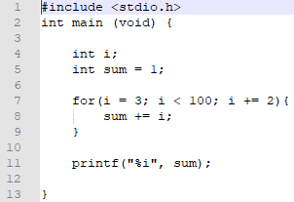

Essentially, we just want to create a program that loops by checking that the index we’re using as the condition has not exceeded 100. In the assembly program, since I ended up putting the conditional after the loop rather than before it, I had to check before the number stored in the conditional before it was incremented instead of after. In this sense, the code I created is much closer to a do…while() loop, since in those the condition check is also after the increment.

As for evidence that the program is working, here is a screenshot:

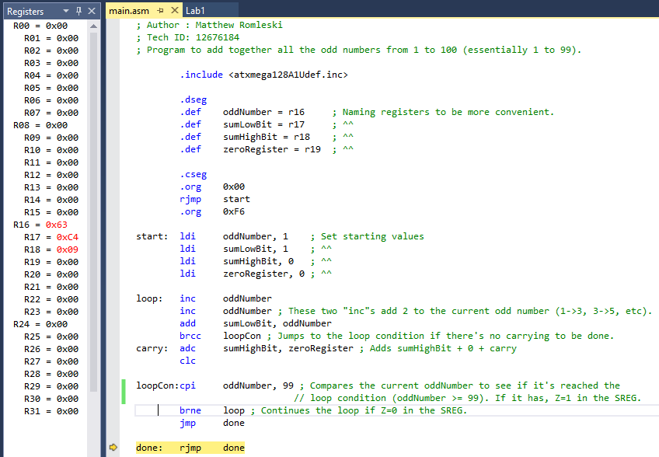

We can look at the registers when the program finishes. In r16 (the number being added), we have ${63}_{16}={99}_{10}$ and in registers r18+r17, we have ${09C4}_{16}={2500}_{10}$, which is the same as number as $1+3+…+99$.